- Using the Library Management System scenario, analyze how class diagrams and sequence diagrams can be used to model the system's structure and behavior. How do these diagrams help in understanding the relationships between classes and the flow of interactions during key processes like borrowing a book? What challenges might arise when creating these diagrams, and how can they be resolved to ensure accurate system design?

Library Management System: Class Diagram and Sequence Diagram

1. Class Diagram – System Structure
A class diagram represents the static structure of the Library Management System. It shows classes, attributes, methods and relationships.
Main classes:
- User – userId, name; borrowBook()
- Student – inherits User.
- Librarian – inherits User; addBook(), issueBook()
- Book – bookId, title, ISBN, status.
- Borrowing – borrowDate, returnDate, status.
Relationships:
- Inheritance: Student and Librarian → User
- Association: User → Borrowing → Book
- Aggregation: Library → Books
- Multiplicity: One user can have multiple borrowing records.
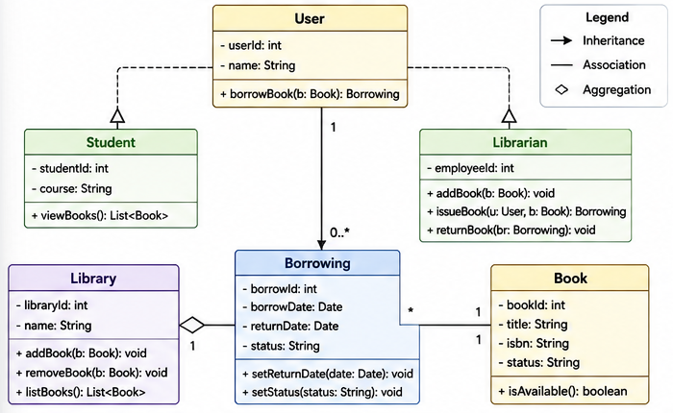

2. Sequence Diagram – System Behavior
A sequence diagram represents the dynamic behavior of the system. It shows the order of messages between objects over time.

Borrow Book Process
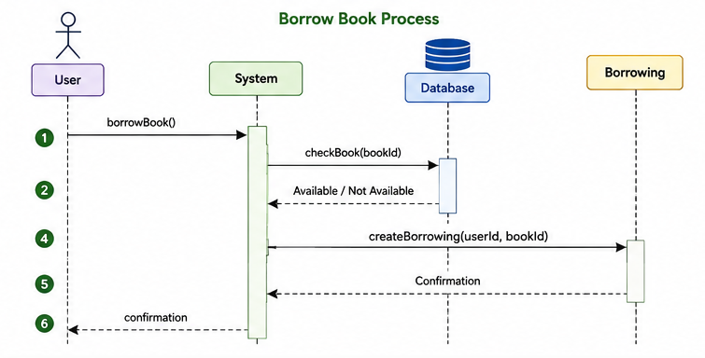
Flow:
- User requests to borrow a book.
- System checks book availability.
- Database returns availability.
- System creates a borrowing record.
- System confirms the borrowing to the user.

3. Importance of Both Diagrams
Class Diagram | Sequence Diagram
Shows structure | Shows behavior
Static view | Dynamic view
Shows classes and relationships | Shows messages and interactions
Helps database/class design | Helps understand process flow
Together:
Class Diagram = What the system contains
Sequence Diagram = How the system works

4. Challenges and Solutions
Challenge | Solution
Identifying correct classes | Analyze use cases and identify important nouns
Complex diagrams | Divide into packages/modules
Unclear requirements | Discuss with stakeholders and use prototypes
Diagram inconsistency | Perform reviews and maintain traceability
Too much detail | Use appropriate abstraction level

Example
For Borrow Book:
Class Diagram:
User — Borrowing — Book
Sequence Diagram:
User → System → Database → Borrowing → User

Memorization Technique
Remember “S-B-C”
S → Structure → Class Diagram
B → Behavior → Sequence Diagram
C → Challenges → Review & Refine
One-line memory:
“Class tells WHAT, Sequence tells HOW.”

- A software development team is designing an Online Shopping System where customers can browse products, add items to a cart, and place orders. The system also allows administrators to manage inventory and process orders.
  - Identify the key use cases (e.g., "Add to Cart," "Place Order") and map them to the objects involved (e.g., Customer, Product, Cart, Order).
  - Create a class diagram showing the relationships between objects, such as how a Customer associates with a Cart and how a Cart aggregates Product objects.
  - Identify any inheritance relationships, such as different types of users (e.g., Customer and Admin inheriting from a User class).
  - Explain how these modeling techniques help in understanding the behavior and structure of the Online Shopping System.
  - Provide examples to illustrate your answer.

Online Shopping System – Use Cases and Class Diagram

1. Key Use Cases and Objects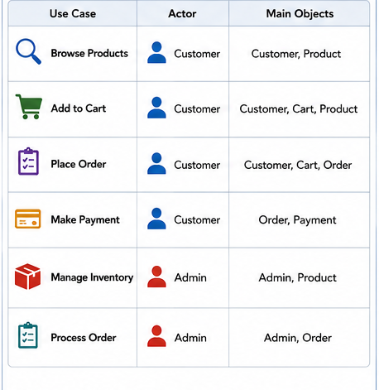2. Class Diagram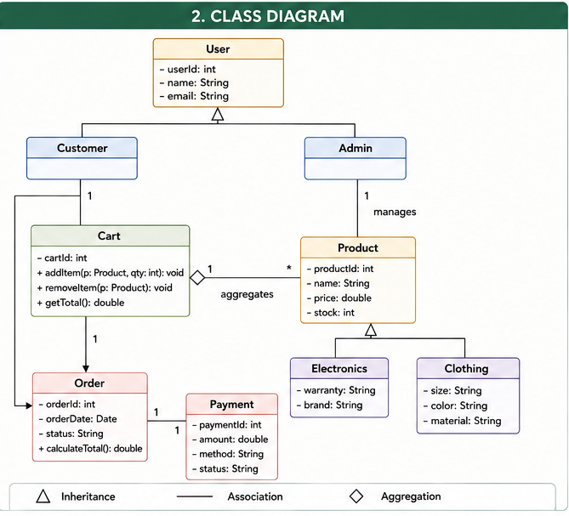

3. Relationships
- 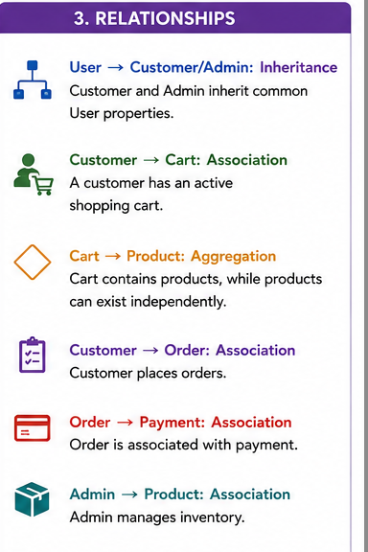

4. Example: Add to Cart
- 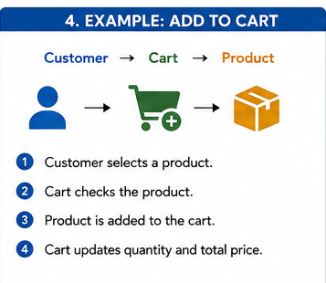

5. Example: Place Order
- 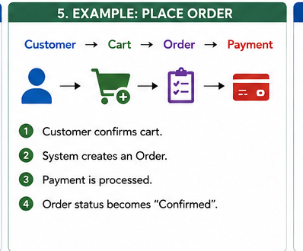

6. Importance of Modeling
- 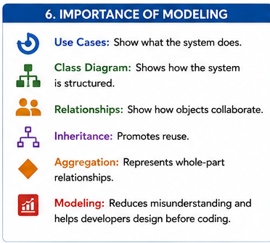

Memorization Technique
Use Case = “What?”
Class Diagram = “What objects?”
Sequence Diagram = “How/When?”
Remember relationships: “I-A-A”
I → Inheritance → User → Customer/Admin
A → Association → Customer → Cart/Order
A → Aggregation → Cart → Product

- What is inheritance? Explain the significance of inheritance in the software development process?

Inheritance
Inheritance is an Object-Oriented Programming (OOP) mechanism in which a subclass acquires the attributes and methods of a superclass.
It represents an “is-a” relationship.
Example:
Car is a Vehicle
Student is a User

Significance of Inheritance
- Code Reusability – Reuses attributes and methods of the superclass.
- Reduces Redundancy – Common features are defined only once.
- Easy Maintenance – Changes in the superclass can be reflected in subclasses.
- Extensibility – New specialized classes can be created easily.
- Better Organization – Creates a clear hierarchy of related classes.
- Supports Polymorphism – Different subclasses can be treated as objects of the superclass.
- Reduces Development Time – Developers build new classes using existing functionality.

Example
User
△
┌────┴────┐
Customer Admin
User: name, email, login()
Customer: inherits User + placeOrder()
Admin: inherits User + manageProduct()
Thus, Customer and Admin reuse the common features of User.

Conclusion
Inheritance improves reusability, maintainability, extensibility and organization of software by creating a hierarchy of related classes.

Memorization Technique
Remember “R-R-M-E-P-O”
R → Reusability
R → Reduces redundancy
M → Maintenance
E → Extensibility
P → Polymorphism
O → Organization
One line:
“Inheritance = Is-a + Reuse + Hierarchy.”
Files, images, and data analysis are unavailable until usage resets at 12:03 PM. Continue chatting with text only, or upgrade for more access.

- Explain the terms Encapsulation and Abstraction in the context of software engineering? How these features in OOP contribute in the development of complex real-world application?

Encapsulation and Abstraction in Software Engineering

1. Encapsulation
Encapsulation is an OOP mechanism of bundling data (attributes) and the methods that operate on that data into a single unit called a class.
It also protects the internal state of an object by restricting direct access to its data.
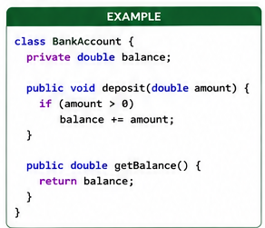
Here:
- balance is private, so it cannot be directly modified from outside.
- deposit() and getBalance() provide controlled access.
- The internal implementation is protected from misuse.

Advantages of Encapsulation
- Data security – prevents unauthorized direct access.
- Information hiding – hides internal implementation details.
- Maintainability – internal implementation can be changed without affecting other classes.
- Modularity – data and related operations are kept together.
- Reduced coupling – classes depend mainly on well-defined interfaces.

2. Abstraction
Abstraction is the process of hiding unnecessary implementation details and exposing only the essential features of an object.
It mainly focuses on:
What an object does, rather than how it does it.

Real-world example
When using an ATM, a user can:
- Withdraw money
- Deposit money
- Check balance
The user does not need to know how the ATM internally communicates with the bank database.
This is abstraction.
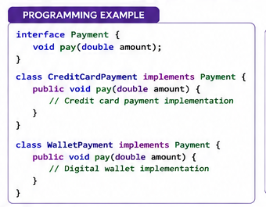
The application only needs to know:
payment.pay(1000);
It does not need to know the internal payment-processing mechanism.

3. Difference Between Encapsulation and Abstraction
Encapsulation | Abstraction
Bundles data and methods together | Hides unnecessary implementation details
Focuses on how data is protected | Focuses on what is exposed
Achieved using classes and access modifiers | Achieved using interfaces, abstract classes, etc.
Provides information hiding | Provides complexity hiding
Example: private balance | Example: Payment.pay()

Easy way to remember
Encapsulation = Hide the data
Abstraction = Hide the complexity

4. Contribution to Complex Real-World Applications
Encapsulation and abstraction are extremely important when developing large applications such as banking systems, e-commerce platforms, hospital systems, and food-delivery applications.

1. Managing Complexity
Large applications contain thousands of classes and functions.
Abstraction allows developers to focus on only the required functionality.
For example:
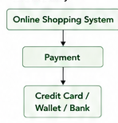
The order system does not need to understand the internal implementation of every payment method.

2. Improving Security
Encapsulation prevents direct manipulation of sensitive information.
For example:
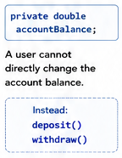
can control how the balance is modified.

3. Improving Maintainability
Suppose a payment algorithm changes from one payment provider to another.
With abstraction, the rest of the application can continue using:
payment.pay(amount);
Only the internal implementation needs to change.

4. Reusability
Encapsulated classes can be reused in different parts of an application.
For example:
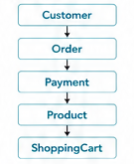
Each class manages its own data and behavior and can be reused throughout the system.

5. Reducing Coupling
Abstraction allows different components to communicate through clearly defined interfaces.
For example:
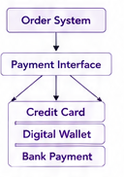
The order system does not depend heavily on the internal implementation of each payment method.

6. Supporting Scalability
New functionality can be added without heavily modifying existing code.
For example, an e-commerce system initially supports:
Credit Card
Digital Wallet
Later, Bank Transfer can be added as another implementation of the Payment abstraction.

5. Conclusion
Encapsulation and abstraction are fundamental OOP principles for controlling complexity in software engineering.
- Encapsulation protects data by combining data and methods and controlling access to internal state.
- Abstraction hides unnecessary implementation details and exposes only essential functionality.
Together, they provide security, modularity, maintainability, reusability, flexibility, and scalability, making them essential for developing complex real-world software systems.

⭐ Exam memory trick
Remember:
E = Encapsulation → Enclose and protect data
A = Abstraction → Avoid unnecessary details
“Encapsulation protects; Abstraction simplifies.”

- Discuss the four fundamental principles of Object-Oriented Analysis and Design (OOAD): Encapsulation, Abstraction, Inheritance, and Polymorphism. Explain how each principle contributes to effective software design, and support your explanation with relevant real-world examples.

Four Fundamental Principles of OOAD with Room Rent System
The four fundamental principles of Object-Oriented Analysis and Design (OOAD) are Encapsulation, Abstraction, Inheritance, and Polymorphism. These principles help developers manage complexity, improve reusability, and develop maintainable software.

1. Encapsulation
Encapsulation is the process of bundling data and the methods that operate on that data into a single class and restricting direct access to the internal data.

Room Rent Example
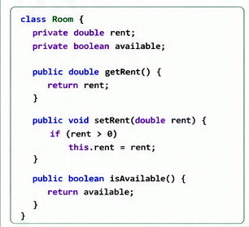
Here, rent and available are private. Other classes cannot directly modify them.
For example:
Tenant → Room → setRent()
The system can control whether the rent value is valid.

Significance
- Protects room and tenant information.
- Prevents unauthorized modification.
- Improves data integrity.
- Makes the system easier to maintain.
- Reduces coupling between classes.

2. Abstraction
Abstraction means hiding unnecessary implementation details and showing only the essential functionality.
It focuses on:
What the system does, rather than how it does it.

Room Rent Example
Suppose a room-rental system provides:
Tenant
↓
Rent Payment
↓
Pay Rent
The tenant only needs to select "Pay Rent".
The tenant does not need to know how the system:
- validates the tenant,
- calculates the rent,
- communicates with the payment service,
- records the transaction,
- generates the receipt.
For example:
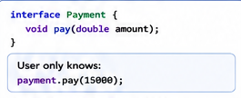
The internal payment process is hidden.

Significance
- Reduces system complexity.
- Makes the system easier to understand.
- Provides a simple interface to users.
- Allows implementation details to change without affecting users.
- Supports flexible and scalable design.
Easy memory:
👉 Abstraction = Hide the complexity

3. Inheritance
Inheritance allows a subclass to acquire the attributes and methods of a superclass.
It represents an "is-a" relationship.

Room Rent Example
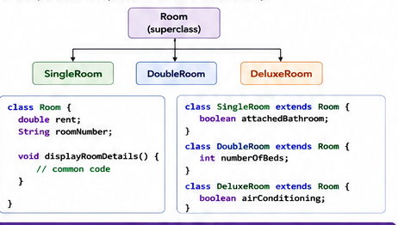
Here:
- SingleRoom is a Room
- DoubleRoom is a Room
- DeluxeRoom is a Room

Significance
- Promotes code reuse.
- Reduces duplicate code.
- Organizes classes into a hierarchy.
- Makes maintenance easier.
- Allows specialized classes to add their own features.
Easy memory:
👉 Inheritance = Reuse from parent

4. Polymorphism
Polymorphism means "many forms." It allows different classes to respond to the same method or interface in different ways.

Room Rent Example
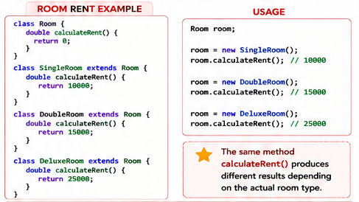.

Significance
- Provides flexibility.
- Reduces dependency between classes.
- Makes systems easier to extend.
- Allows new room types to be added without changing existing code extensively.
- Supports dynamic behavior.
Easy memory:
👉 Polymorphism = Same method, different behavior

Comparison Table
Principle | Meaning | Room Rent Example | Main Benefit
Encapsulation | Protect and bundle data | Private room rent | Security
Abstraction | Hide unnecessary details | payRent() hides payment process | Simplicity
Inheritance | Acquire features from parent | SingleRoom extends Room | Reusability
Polymorphism | Same interface, different behavior | Different calculateRent() | Flexibility

How They Work Together
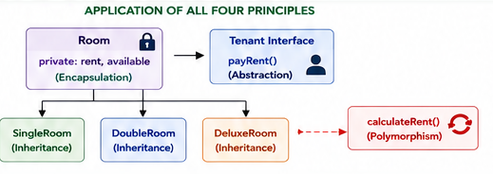

Final exam conclusion
The four principles of OOAD provide a strong foundation for developing complex software. Encapsulation protects data, abstraction hides complexity, inheritance promotes reuse, and polymorphism provides flexibility. In a Room Rent Management System, these principles can be used together to create a system that is secure, reusable, maintainable, flexible, and scalable.

⭐ Super-easy memory trick
E → Protect → Encapsulation
A → Hide → Abstraction
I → Reuse → Inheritance
P → Different behavior → Polymorphism
“Protect → Hide → Reuse → Different Behavior.”

- A bank wants to develop an online banking system that allows customers to check balances, transfer money, and pay bills. The system should also have an admin panel to manage customer accounts and transactions.
  - Draw a Use Case Diagram for this system and describe the key actors and their roles.
  - Also, explain how Entity, Boundary, and Control Objects can be used in the design process.

Online Banking System – Use Case Diagram and ECB Objects

1. Introduction
An Online Banking System allows customers to perform banking activities such as checking account balances, transferring money, paying bills, and viewing transaction history. An Admin manages customer accounts and monitors transactions.
The system can be modeled using a Use Case Diagram and the Entity–Boundary–Control (EBC/ECB) approach.

2. Key Actors and Their Roles

1. Customer
The main user of the banking system.
Responsibilities:
- Login
- Check balance
- Transfer money
- Pay bills
- View transaction history

2. Admin
The administrator manages and monitors the banking system.
Responsibilities:
- Manage customer accounts
- Manage transactions
- Generate reports

3. External Bill Payment Service
An external system used to process bill payments.
Responsibility:
- Process and confirm bill payments.

3. Use Cases

Customer Use Cases
- Login
- Check Balance
- Transfer Money
- Pay Bills
- View Transaction History

Admin Use Cases
- Login
- Manage Customer Accounts
- Manage Transactions
- Generate Reports

4. Use Case Diagram
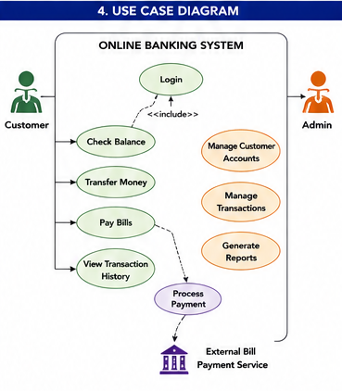

5. Entity, Boundary and Control Objects
The Entity–Boundary–Control (EBC) approach divides objects according to their responsibilities.
A simple way to remember it is:
Entity = Data
Boundary = Interface
Control = Logic

A. Entity Objects
Entity objects represent important business information that needs to be stored and maintained.

Examples
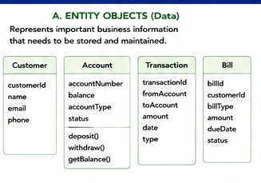

Role
Entity objects:
- Store persistent information.
- Represent important business concepts.
- Maintain business data.
- Usually correspond to database records.

B. Boundary Objects
- 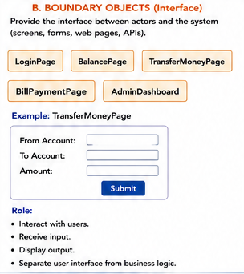

C. Control Objects
Control objects coordinate the activities required to complete a use case.
They act as the bridge between Boundary and Entity objects.

Examples
- 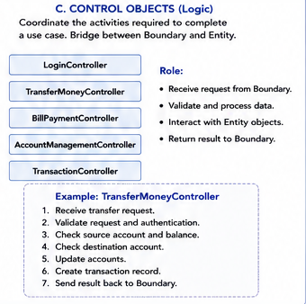

6. Complete Example: Transfer Money
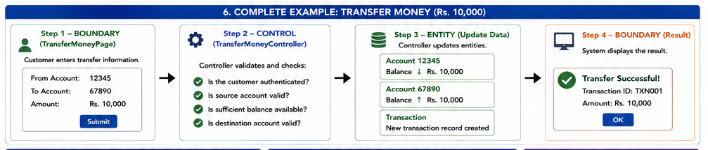
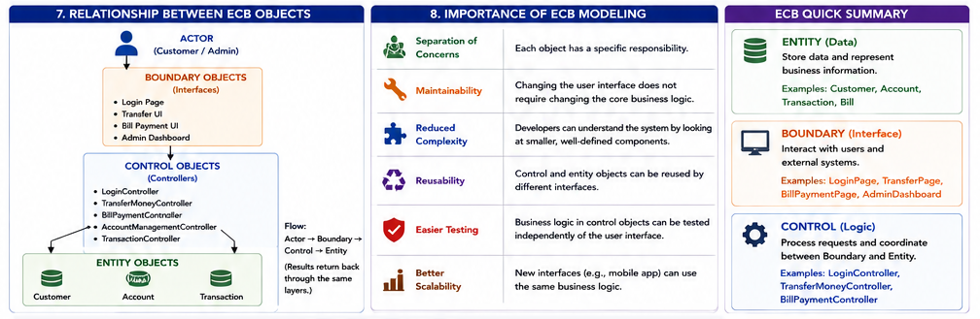

9. Final Conclusion
The Use Case Diagram identifies what the Online Banking System should do and who interacts with it. The Customer performs banking operations, while the Admin manages accounts and transactions.
The Entity–Boundary–Control model then helps transform these requirements into a structured design:
Entity → stores data
Boundary → interacts with users
Control → manages business logic
Together, these techniques provide a clear understanding of both the functional requirements and internal design of the Online Banking System, resulting in a system that is easier to develop, test, maintain, and extend.

- A university is facing challenges in verifying the identity of students accessing its online academic services such as course registration, examination portals, and digital transcripts. To address this, the university plans to implement a multi-factor authentication (MFA)-based digital identity verification system (DIVS).
In this process, a student logs into the university portal using their credentials (registration number and password), followed by additional verification methods such as a One-Time Password (OTP) sent to their registered email. The system may also validate student records against the university database to ensure authenticity. This approach helps the university prevent unauthorized access, reduce impersonation during online examinations, and ensure secure access to sensitive academic information and services.
Develop a use case description for the Digital Identity Verification System (DVIS). Your answer should include the primary and secondary actors, preconditions, main flow of events, alternative/exception flows, and postconditions.
